**THE TRAGEDY OF FLIGHT: A COMPREHENSIVE CRASH ANALYSIS**

**Project Report Template**

**1.INTRODUCTION 1.1 OVERVIEW**

An airplane crash analysis is a detailed investigation into the causes of an aviation accident. The goal of an airplane crash analysis is to identify any factors that contributed to the accident, with the ultimate goal of improving safety and preventing future accidents. The process of conducting an airplane crash analysis typically involves the collection and analysis of a wide range of data, including information about the aircraft and its systems, the operators, and any other relevant factors. This data is typically collected from Kaggle. Once the data has been collected, it is analysed through tableau, to identify any potential causes of the accident. The results of an airplane crash analysis are typically published in a report, which may include recommendations for improving safety and preventing similar accidents in the future. These recommendations may be implemented by the relevant authorities or industry organizations.

**1.2.2PURPOSE**

* Traffic Crash Analysis can be used to analyze crash data and identify streets and intersections where concentrations of serious and fatal crashes occur.
* Traffic Crash Analysis is typically implemented by transportation, public works, and public safety agencies that want to use data-driven strategies to improve safety along the transportation network

**2.PROBLEM DEFINITION AND DESIGN THINKING**

**2.1 EMPATHY MAP**

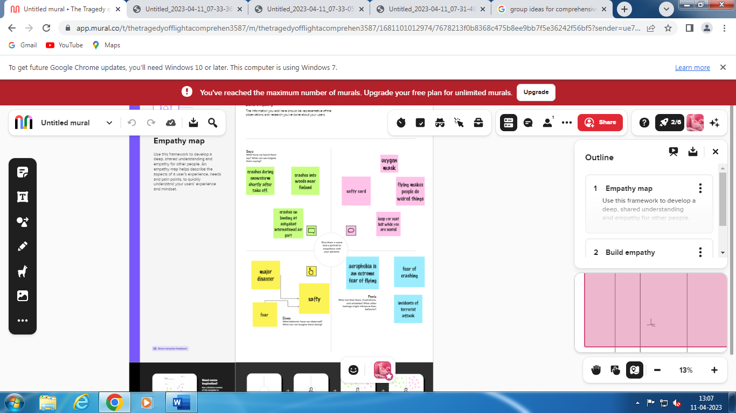

**2.2 IDEATION AND BRAINSTORMING MAP**

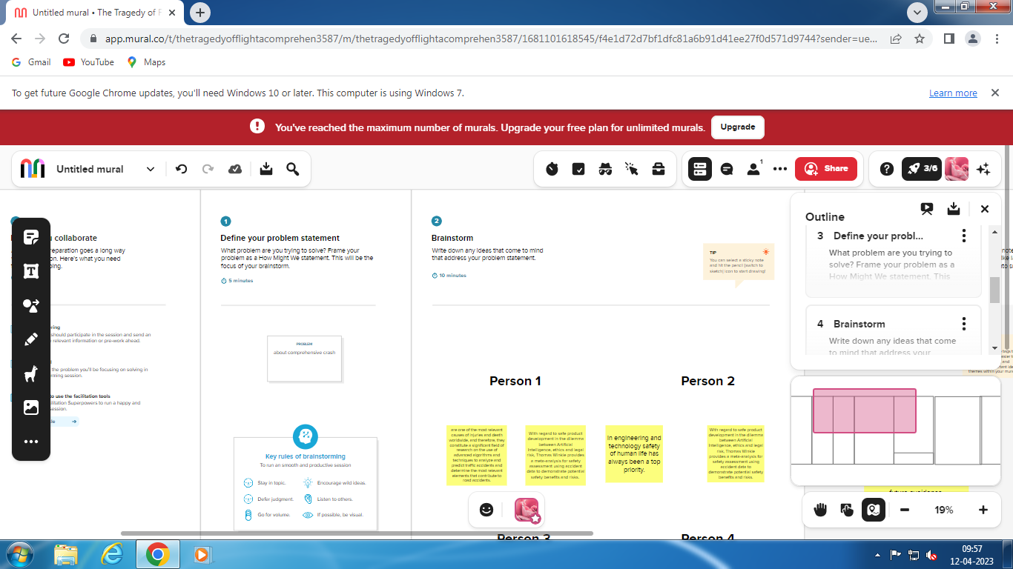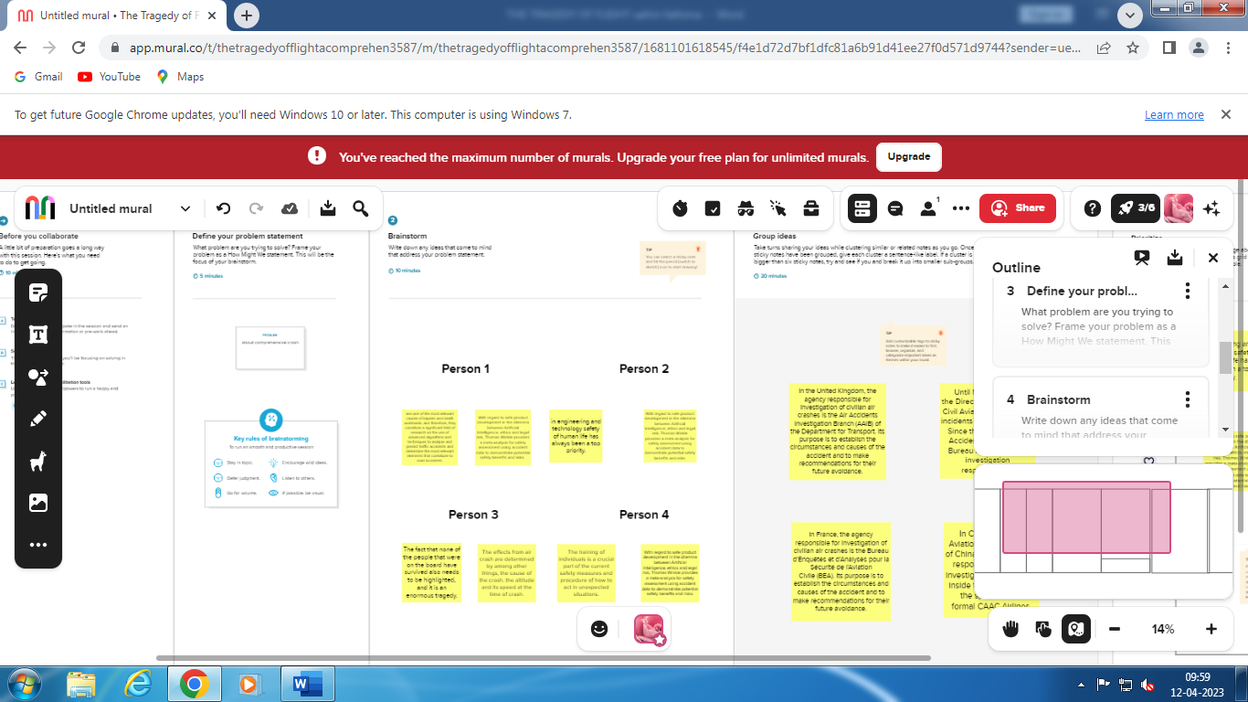

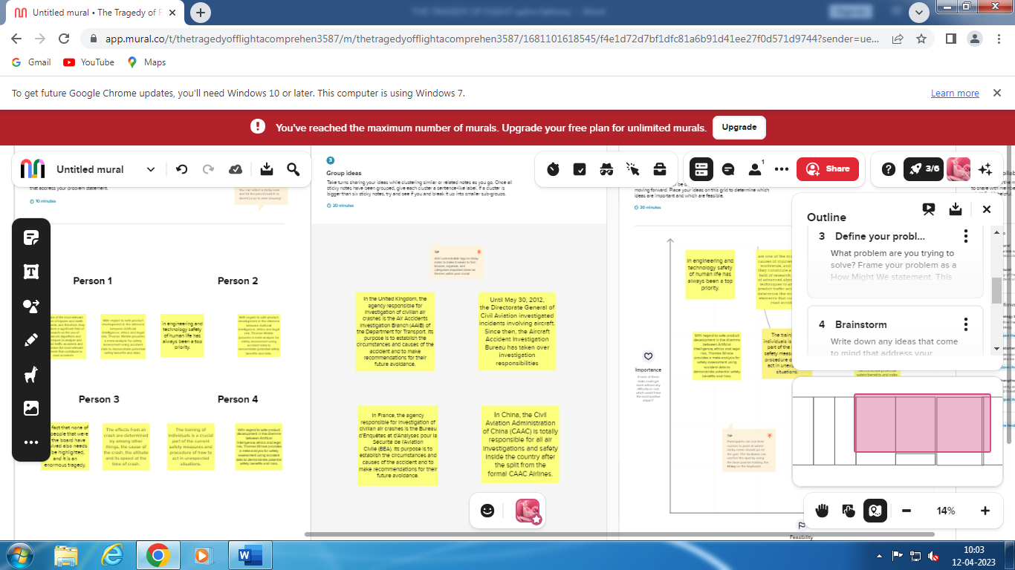 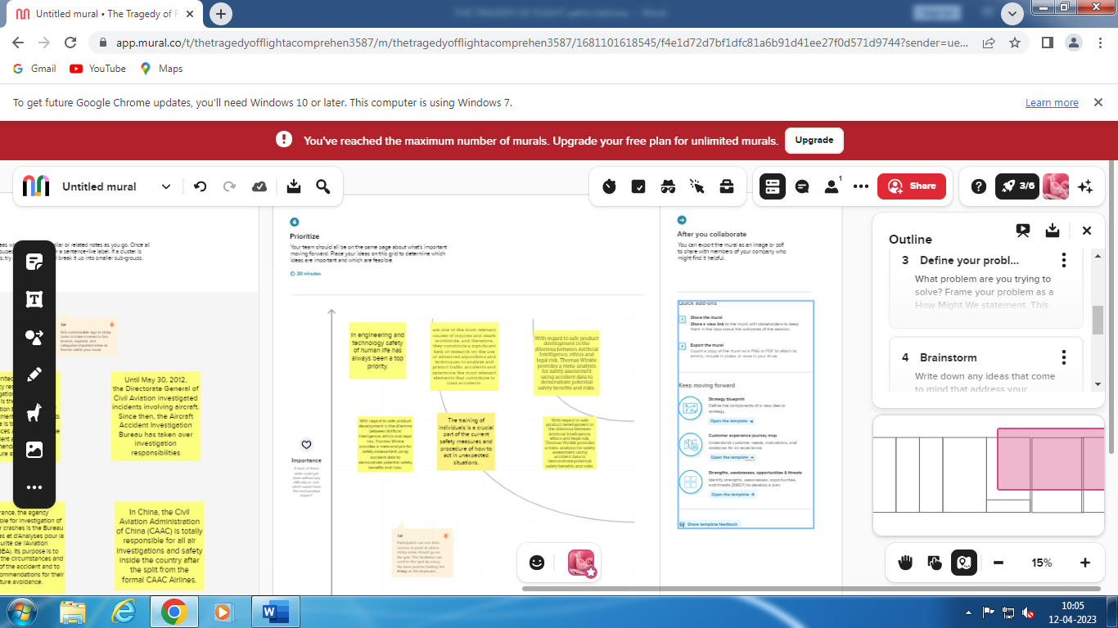

**3.** **RESULT**

Aviation accident analysis is performed to determine the cause of errors once an accident has happened. In the modern aviation industry, it is also used to analyze a database of past accidents in order to prevent an accident from happening. Many models have been used not only for the accident investigation but also for educational purpose

**4. ADVANTAGES AND DISADVANTAGES**

**ADVANTAGES**

* Accident analysis is a major tool in obtaining an understanding of the existing situation and how it could be improved by ITS. It helps to provide an understanding of the most effective solutions and is essential for monitoring and evaluating the safety of the air network.
* The purpose of a crash analysis is to see how the Aeroplane will behave in a frontal or sideways collision. Crashworthiness simulation is one typical area of application of Finite-Element Analysis (FEA). This is an area in which non-linear Finite Element simulations are particularly effective.

**DISADVANTAGE**

* The odds of dying in a plane crash are about one in 11 million, but the chances of surviving depend on your seating choice. An aviation expert reveals a 44 percent fatality rate for travellers sitting in the aisle seats in the middle of the craft, compared with 28 percent for central rear seats**.**
* Passengers at the front of the aircraft had a 65 percent chance of escape, while those at the rear had only a 53 percent chance.

**5. APPLICATIONS**

* Crash Analysis can be used to analyses crash data and identify streets and intersections where concentrations of serious and fatal crashes occur. Safety is one of the most important factors to consider when evaluating air network.
* Software lets engineers run crash tests inside computers rather than on roads. It also allows them to compare the performance of different designs early in the process while cars are still on the drawing board, saving money and injuries.
* The purpose of a crash analysis is to see how the car will behave in a frontal or sideways collision. Crashworthiness simulation is one typical area of application of Finite-Element Analysis (FEA). This is an area in which non-linear Finite Element simulations are particularly effective.

**6. CONCLUTION**

A number of studies have attempted to ascertain whether NHTSA frontal crash tests reflect real-world crash outcomes.  Generally, studies that restrict the range of crashes considered as closely as possible to the specific circumstances of the crash test (head-on collision with the driver wearing seat belts) indicate a substantial difference in risk of fatality or serious injury for vehicles with better crash test performance compared to those with worse crash test performance.  But outside those specific circumstances, six studies provide little evidence that crash test performance consistently signals safety in the *general* circumstances of a serious crash.  But these studies did not adequately address the problem of driver heterogeneity: systematic differences in the distribution of driver characteristics including propensity for riskier driving behaviors.  Our analytical approach is quite different in that we take only the information from different crash test ratings within a vehicle line to test whether crash test ratings predict driver fatality risk.  So instead of obtaining information on fatality risk and ratings from, in effect, comparing a high-performance sports car with better crash test ratings to a staid sedan with lower ratings, we construct our estimates from differences in fatality risk when the sports car or the staid sedan are re-tested.  By doing so, we control for such differences in driver heterogeneity that persist within a vehicle line.

**7. FUTURE SCOPE**

According to FMI, the Automotive Active Safety System market is estimated to be valued at US$ 12.78 Billion in 2022 and is projected to increase at a CAGR of 11.2% in the forecast period from 2022 to 2032. The global market for automotive active safety systems is expected to grow by an 11.2% CAGR in the next ten years.

Traffic Crash Analysis can be used to analyse crash data and identify streets and intersections where concentrations of serious and fatal crashes occur. Safety is one of the most important factors to consider when evaluating a road network.

Automatic crash detection provides insurers with early notification of loss (eFNOL) and enables immediate assistance to the policyholder − both for quick and cheap loss settlement and saving their health or life.

**8. APPENDIX**

1. Introduction.

2. Problem Definition & Design Thinking.

3. Result.

4. Advantages & Disadvantages.

5. Applications.

6. Conclusion.

7. Future Scope.